Nama : Muhammad Faiq assajjad

Nim : 24060122140116

i. function fmatakuliahall menghitung banyaknya semua isi tabel matakuliah.

Query :

USE Akademikdb;

GO

CREATE FUNCTION dbo.fmatakuliahall1()

RETURNS int

AS

BEGIN

RETURN (SELECT COUNT(\*) FROM Matakuliah);

END;

GO

USE AKADEMIKDB;

DECLARE @nbkuliah INT;

SET @nbkuliah = dbo.fmatakuliahall1()

SELECT @nbkuliah

Screenshoot :

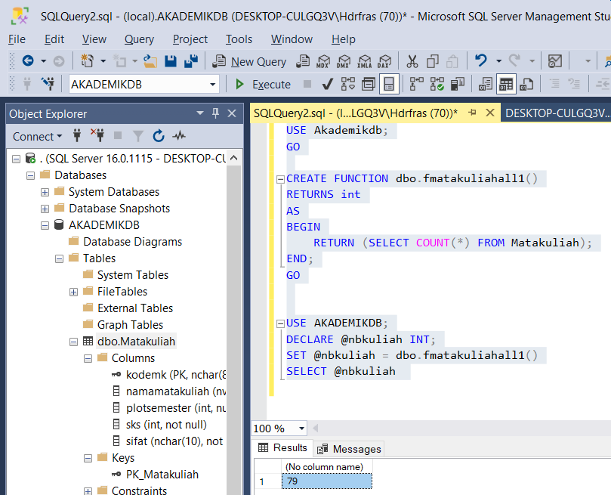

ii. function fmatakuliahwajib menghitung banyaknya mata kuliah wajib.

Query :

USE Akademikdb;

GO

CREATE FUNCTION dbo.fmatakuliahwajib1()

RETURNS int

AS

BEGIN

RETURN (SELECT COUNT(\*) FROM Matakuliah WHERE sifat = 'W');

END;

GO

USE AKADEMIKDB;

DECLARE @nbkuliah INT;

SET @nbkuliah = dbo.fmatakuliahwajib1()

SELECT @nbkuliah

Screenshoot :

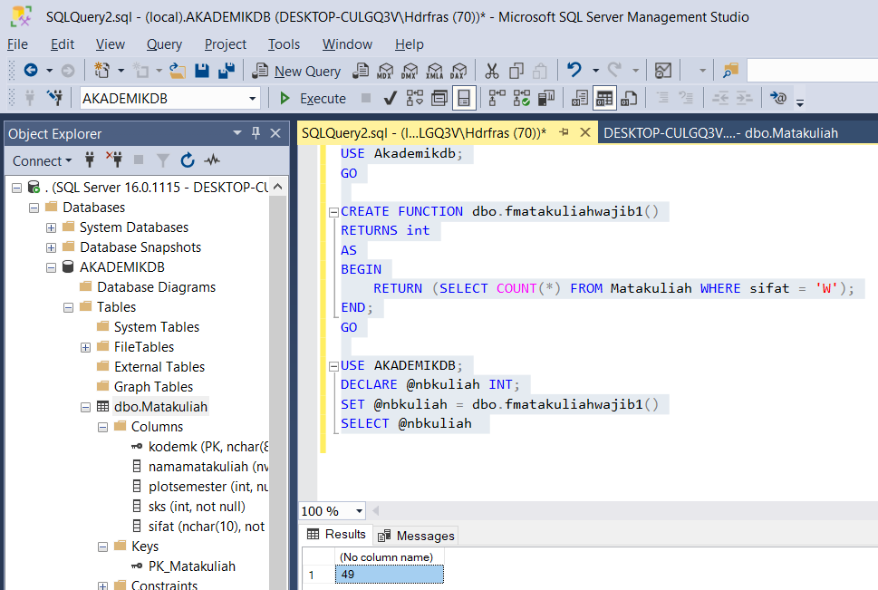

iii. function fmatakuliahpilihan menghitung banyaknya mata kuliah pilihan.

Query :

USE Akademikdb;

GO

CREATE FUNCTION dbo.fmatakuliahpilihan()

RETURNS int

AS

BEGIN

RETURN (SELECT COUNT(\*) FROM Matakuliah WHERE sifat = 'P');

END;

GO

USE AKADEMIKDB;

DECLARE @nbkuliah INT;

SET @nbkuliah = dbo.fmatakuliahpilihan()

SELECT @nbkuliah

Screenshoot :

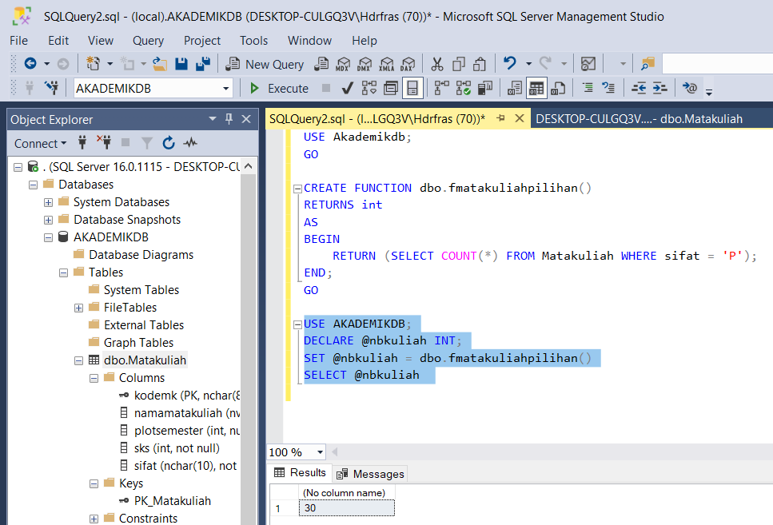

iv. function fmatakuliahgenap menghitung banyaknya tabel matakuliah yang dibuka pada semester

genap

Query :

USE Akademikdb;

GO

CREATE FUNCTION dbo.fmatakuliahgenap11()

RETURNS int

AS

BEGIN

RETURN (SELECT COUNT(\*) FROM Matakuliah WHERE plotsemester % 2 = 0);

END;

GO

USE AKADEMIKDB;

DECLARE @nbkuliah INT;

SET @nbkuliah = dbo.fmatakuliahgenap11()

SELECT @nbkuliah

Screenshoot :

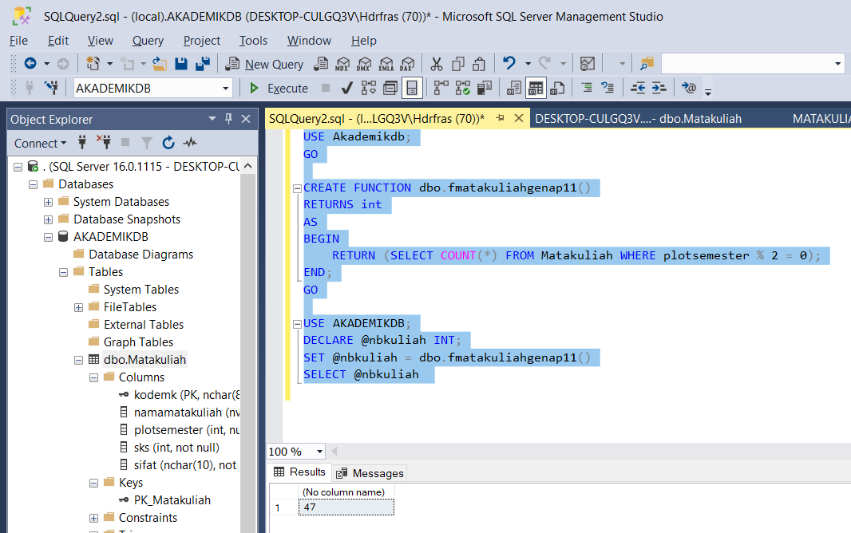

v. function fmatakuliahgasal menghitung banyaknya tabel matakuliah yang dibuka pada semester

ganjil

Query :

USE Akademikdb;

GO

CREATE FUNCTION dbo.fmatakuliahganjil()

RETURNS int

AS

BEGIN

RETURN (SELECT COUNT(\*) FROM Matakuliah WHERE plotsemester % 2 <> 0);

END;

GO

USE AKADEMIKDB;

DECLARE @nbkuliah INT;

SET @nbkuliah = dbo.fmatakuliahganjil()

SELECT @nbkuliah

Screenshoot :

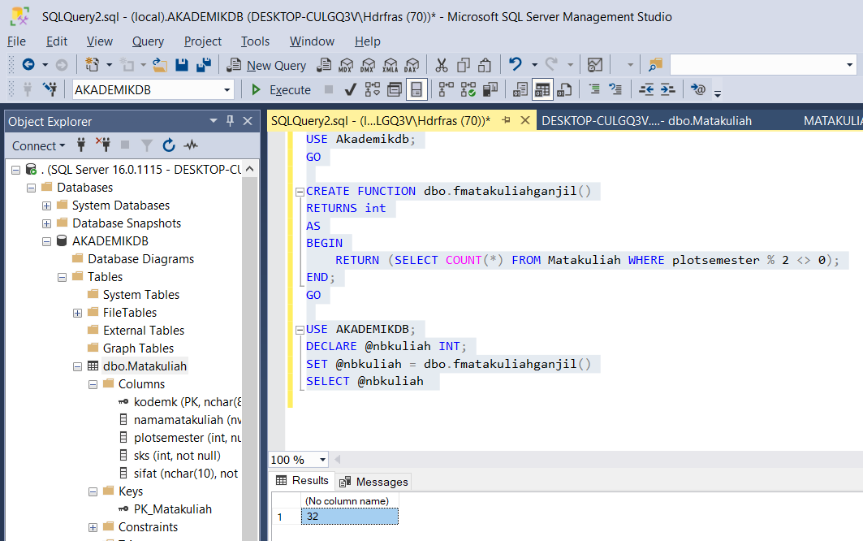

vi. function fmatakuliahopen menghitung banyaknya tabel matakuliah yang dibuka pada semua

semester

Query :

USE Akademikdb;

GO

CREATE FUNCTION dbo.fmatakuliahopen()

RETURNS int

AS

BEGIN

RETURN (SELECT COUNT(\*) FROM Matakuliah WHERE plotsemester = 0);

END;

GO

USE AKADEMIKDB;

DECLARE @nbkuliah INT;

SET @nbkuliah = dbo.fmatakuliahopen()

SELECT @nbkuliah

Screenshoot :

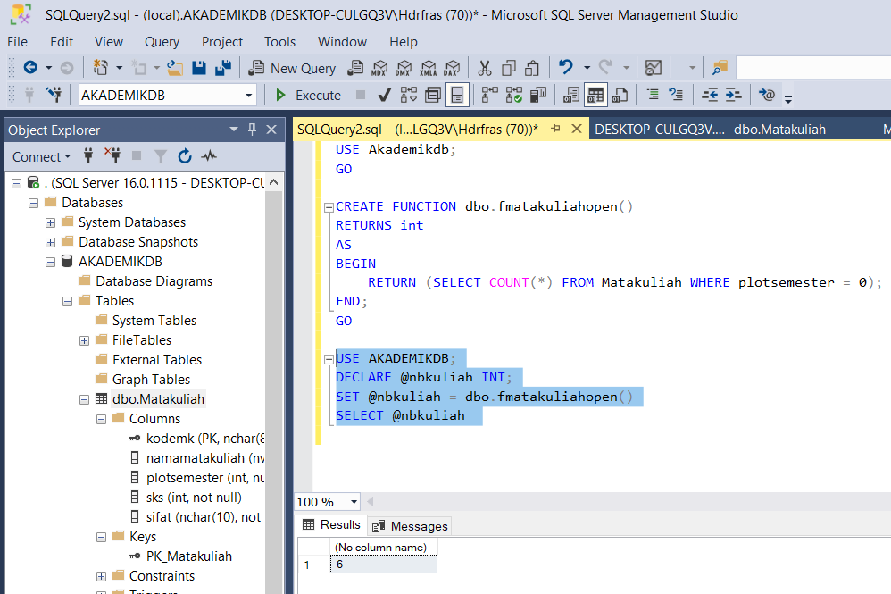

vii. function fmatakuliah(semester:integer) menghitung banyaknya matakuliah pada semester

tertentu

Query :

USE Akademikdb;

GO

CREATE FUNCTION dbo.fmatakuliah1()

RETURNS int

AS

BEGIN

RETURN (SELECT COUNT(\*) FROM Matakuliah WHERE plotsemester = 1);

END;

GO

USE AKADEMIKDB;

DECLARE @nbkuliah INT;

SET @nbkuliah = dbo.fmatakuliah1()

SELECT @nbkuliah

Screenshoot :

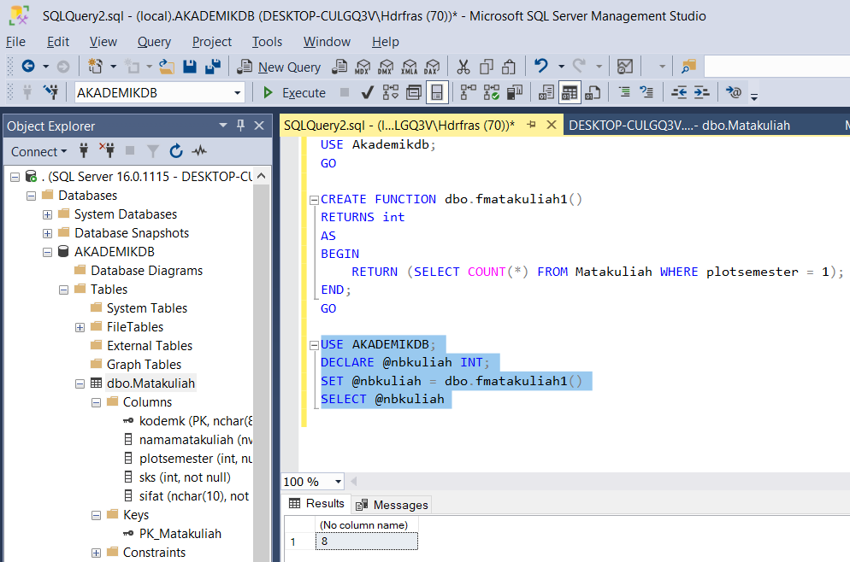

viii. Function fbeban(semester:integer) menghitung banyaknya sks pada semester tertentu

Query :

USE Akademikdb;

GO

CREATE FUNCTION dbo.beban()

RETURNS int

AS

BEGIN

RETURN (SELECT SUM(sks) FROM Matakuliah WHERE plotsemester = 1);

END;

GO

USE AKADEMIKDB;

DECLARE @nbkuliah INT;

SET @nbkuliah = dbo.beban()

SELECT @nbkuliah

Screenshoot :

